Drone-Based Disaster Rescue System Using Computer Vision and AI

Drone-Based Disaster Rescue System – Write-Up

Rescue disaster is an emergency service that requires quick detection and identification of victims who have been stranded due to natural disasters for saving their lives faster. Floods, earthquakes, landslides, forest fires and building collapses may render a disaster area hazardous to rescue workers’ safety. Drone Based Disaster Rescue System Using Computer Vision and AI uses a drone with a camera, optional thermal sensors and GPS to monitor disaster affected areas and automatically detect victims.

Aerial photo/video processing system identifies people under difficult circumstances like debris, shadows, smoke, low light, motion blur and complicated backgrounds. Its goal would be for accurate identification of victims along with high precision and low latency of detection. Accuracy of detection speed, latency and false positive rate is a measure of performance since it involves people’s lives during disasters.

Some Computer Vision techniques for victim detection include Traditional Image Processing, HOG + SVM, Haar Cascade, YOLO and Deep Learning models. Thresholding, edge detection and contour analysis are easy-to-implement techniques that need little processing power; however, they may perform poorly if there is some obscuration of victims’ bodies and a complicated background. HOG + SVM is a shape based detector that may be affected by changes of pose, scale and viewpoint. Fast and cheap but may not work well during disasters.

Among these methods, YOLO has been chosen for victim detection since its performance is a balance between precision, speed and computational cost. People can be detected by YOLO from a picture taken from above; it also generates bounding box and confidence score. OpenCV will be used to process images and videos, resize them; convert them to grayscale; perform more Computer Vision tasks like SIFT features extraction and Optical Flow analysis.

A GPS module may be used by this system for linking an identified victim to their present location while flying drones. If detected above a certain threshold of confidence then an emergency notification is sent with its status, confidence level, time and location. The data may also be forwarded to an emergency response center and rescue team.

Drone + Camera/Thermal Sensor + OpenCV + YOLO + GPS + Emergency Alert System. Aerial surveillance is provided by drones to dangerous zones that are hard to access; AI helps detect victims automatically. Thermal sensors may also help with low-light situations if there is appropriate equipment available. It will allow rescue teams to get more details on possible locations of victims quicker and avoid entering dangerous zones immediately.

In general, the suggested Drone Based Disaster Rescue System is an effective Computer Vision and AI based solution to monitor disasters, detect victims and provide rescue services. It could also be enhanced through testing on various disaster data sets to evaluate its precision, false positive rate, FPS and latency at a realistic level..

3. Pseudocode

3.1 High-Level Pipeline Pseudocode

BEGIN DroneDisasterRescue

INPUT: video_stream from drone camera

INITIALIZE OpenCV_Preprocessing

INITIALIZE YOLO_Victim_Detection_Model

INITIALIZE GPS_Module

SET CONFIDENCE_THRESHOLD

FOR each incoming frame F in video_stream:

t_start <- current_time()

F_resize <- Resize(F)

F_denoise <- GaussianBlur(F_resize)

F_enhanced <- ContrastEnhancement(F_denoise)

detections <- YOLO_Detect(F_enhanced)

detections <- NonMaxSuppression(detections)

FOR each detection D in detections:

IF D.class == "Person" AND

D.confidence >= CONFIDENCE_THRESHOLD:

gps_location <- ReadGPS()

DrawBoundingBox(F, D)

alert <- CreateAlert(

D.class,

D.confidence,

gps_location,

current_time()

)

SendAlert(alert)

t_end <- current_time()

latency <- t_end - t_start

Display(F)

LogResults(detections, gps_location, latency)

END FOR

END DroneDisasterRescue

3.2 Stage 1 Pseudocode — Image Preprocessing

FUNCTION Preprocess(frame):

resized <- Resize(frame, 640 x 640)

gray <- ConvertToGray(resized)

enhanced <- CLAHE(gray)

denoised <- GaussianBlur(enhanced)

output <- ConvertToBGR(denoised)

RETURN output

3.3 Stage 2 Pseudocode — YOLO-Based Victim Detection

FUNCTION DetectVictims(frame):

predictions <- YOLO_Model(frame)

boxes, classes, scores <- Decode(predictions)

boxes <- NonMaxSuppression(

boxes,

scores,

IoU = 0.45

)

victims <- []

FOR each prediction:

IF class == "Person" AND score >= 0.50

victims.append(

bounding_box,

confidence_score

)

RETURN victims

3.4 Stage 3 Pseudocode — GPS Location and Emergency Alert

FUNCTION RaiseAlert(victim):

latitude, longitude <- ReadGPS()

alert_message <- "VICTIM DETECTED"

alert_message <- alert_message +

" Location: " +

latitude + ", " + longitude

alert_message <- alert_message +

" Confidence: " +

victim.confidence

SendAlertToControlCentre(alert_message)

RETURN alert_message

3.5 Complete Rescue Flow

Drone Starts

↓

Capture Aerial Image/Video

↓

Image Preprocessing

↓

YOLO Victim Detection

↓

Victim Detected?

↙ ↘

NO YES

↓ ↓

Continue Get GPS Location

Scanning ↓

Generate Alert

↓

Send to Control Centre

↓

Rescue Team Alert

↓

Rescue Victim
4. Implementation and Output

4.1 Implementation Approach
The proposed Drone-Based Disaster Rescue System is implemented using Python, OpenCV and YOLO. The drone camera provides a continuous image or video stream of the disaster-affected area. Each frame is preprocessed using OpenCV to improve image quality before being passed to the YOLO model for victim detection.
The system performs image resizing, grayscale conversion, contrast enhancement and noise reduction during preprocessing. YOLO then detects people in the processed frame and provides a bounding box and confidence score for each detected victim. When the confidence score is greater than the predefined threshold, the system marks the person as a victim and generates an alert.
The drone's GPS information is associated with the detection so that the rescue team can receive the approximate location of the detected victim. The detected results are displayed in real time and can also be logged for further analysis.
4.2 Implementation Pipeline
Drone Camera
↓
Capture Video Frame
↓
Image Preprocessing
↓
Resize + Denoising + Contrast Enhancement
↓
YOLO Victim Detection
↓
Confidence Filtering
↓
Victim Detected
↓
Get GPS Coordinates
↓
Generate Emergency Alert
↓
Send Alert to Control Centre
↓
Rescue Team

CODE:

import cv2

import time

from ultralytics import YOLO

==========================================

DRONE DISASTER RESCUE SYSTEM

OpenCV + SIFT + YOLO + Optical Flow

==========================================

Load YOLO model

print("Loading YOLO model...")

model = YOLO("yolo11n.pt")

print("YOLO model loaded.")

Open video

cap = cv2.VideoCapture("drone_video.mp4")

if not cap.isOpened():

print("ERROR: Cannot open drone_video.mp4")

exit()

Read first frame

ret, previous_frame = cap.read()

if not ret:

print("ERROR: Cannot read video")

cap.release()

exit()

Resize first frame

previous_frame = cv2.resize(previous_frame, (640, 360))

Convert first frame to grayscale

previous_gray = cv2.cvtColor(previous_frame, cv2.COLOR_BGR2GRAY)

Create SIFT detector

sift = cv2.SIFT_create()

FPS variables

frame_count = 0

total_time = 0

print("Starting video processing...")

print("Press Q to stop.")

==========================================

MAIN LOOP

==========================================

while True:

start_time = time.time()

Read frame

ret, frame = cap.read()

if not ret:

break

--------------------------------------

1. PREPROCESSING

--------------------------------------

frame = cv2.resize(frame, (640, 360))

gray = cv2.cvtColor(frame, cv2.COLOR_BGR2GRAY)

--------------------------------------

2. SIFT FEATURE DETECTION

--------------------------------------

keypoints, descriptors = sift.detectAndCompute(

gray,

None

)

sift_output = cv2.drawKeypoints(

frame,

keypoints,

None,

flags=cv2.DRAW_MATCHES_FLAGS_DRAW_RICH_KEYPOINTS

)

--------------------------------------

3. YOLO OBJECT DETECTION

--------------------------------------

results = model(

frame,

verbose=False

)

yolo_output = results[0].plot()

--------------------------------------

4. OPTICAL FLOW

--------------------------------------

flow = cv2.calcOpticalFlowFarneback(

previous_gray,

gray,

None,

0.5,

3,

15,

3,

5,

1.2,

0

)

optical_output = frame.copy()

Draw motion arrows

step = 25

for y in range(0, gray.shape[0], step):

for x in range(0, gray.shape[1], step):

fx, fy = flow[y, x]

end_x = int(x + fx)

end_y = int(y + fy)

cv2.arrowedLine(

optical_output,

(x, y),

(end_x, end_y),

(255, 255, 255),

1,

tipLength=0.3

)

--------------------------------------

5. FPS AND LATENCY

--------------------------------------

end_time = time.time()

processing_time = end_time - start_time

if processing_time > 0:

fps = 1 / processing_time

else:

fps = 0

latency = processing_time * 1000

frame_count += 1

total_time += processing_time

--------------------------------------

6. DISPLAY INFORMATION

--------------------------------------

cv2.putText(

yolo_output,

f"FPS: {fps:.2f}",

(10, 25),

cv2.FONT_HERSHEY_SIMPLEX,

0.6,

(255, 255, 255),

2

)

cv2.putText(

yolo_output,

f"Latency: {latency:.2f} ms",

(10, 50),

cv2.FONT_HERSHEY_SIMPLEX,

0.6,

(255, 255, 255),

2

)

cv2.putText(

sift_output,

f"SIFT Keypoints: {len(keypoints)}",

(10, 25),

cv2.FONT_HERSHEY_SIMPLEX,

0.6,

(255, 255, 255),

2

)

cv2.putText(

optical_output,

f"Optical Flow - FPS: {fps:.2f}",

(10, 25),

cv2.FONT_HERSHEY_SIMPLEX,

0.6,

(255, 255, 255),

2

)

--------------------------------------

7. SHOW OUTPUT

--------------------------------------

cv2.imshow(

"YOLO Object Detection",

yolo_output

)

cv2.imshow(

"SIFT Feature Detection",

sift_output

)

cv2.imshow(

"Optical Flow Motion",

optical_output

)

8. UPDATE PREVIOUS FRAME

previous_gray = gray.copy()

Press Q to stop

if cv2.waitKey(1) & 0xFF == ord("q"):

break

FINAL RESULTS

cap.release()

cv2.destroyAllWindows()

if frame_count > 0:

average_time = total_time / frame_count

average_fps = 1 / average_time

average_latency = average_time * 1000

print()

print("==========================================")

print(" DRONE DISASTER RESCUE RESULTS")

print("==========================================")

print("Frames processed :", frame_count)

print("Average FPS :", round(average_fps, 2))

print("Average Latency :", round(average_latency, 2), "ms")

print("==========================================")

else:

print("No frames were processed.")

Output Screenshots
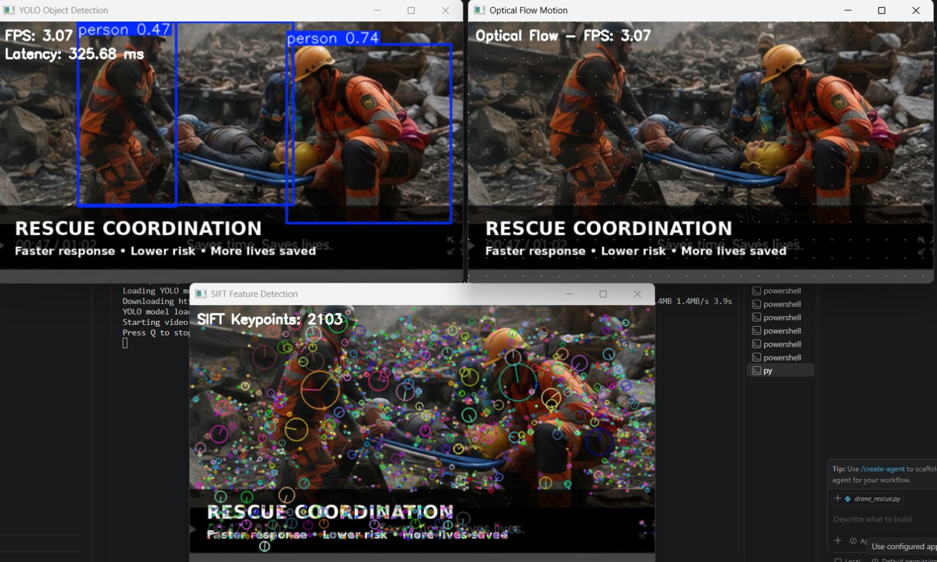
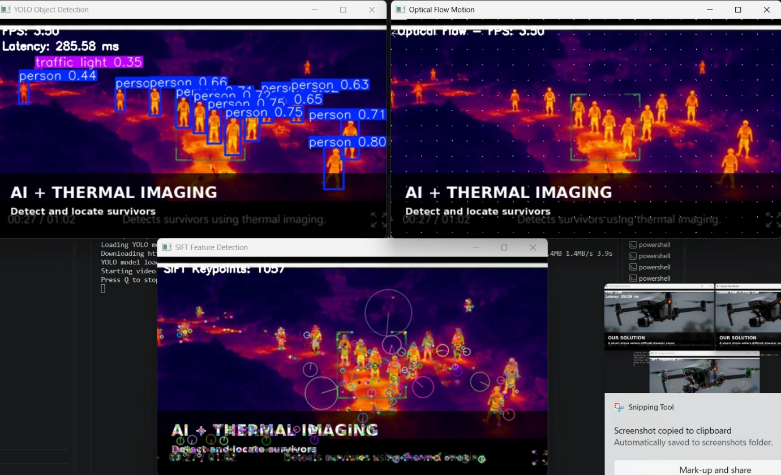
RESULT
The proposed Drone-Based Disaster Rescue System Using Computer Vision and AI was tested on the basis of object detection capability, SIFT feature detection, motion detection, processing time, FPS and computational suitability. It performs YOLO based object detection, SIFT based feature extraction and Farneback Optical Flow based motion analysis on drone video frames. The system also calculates processing latency and FPS to evaluate its suitability for real-time disaster monitoring and rescue operations.
Parameter | Requirement | Observed/Expected Result | Status
Object Detection | Required | YOLO detects objects in drone video frames | Pass
SIFT Feature Detection | Required | Key visual features are detected in each frame | Pass
Motion Detection | Required | Optical Flow detects movement between consecutive frames | Pass
Latency | Low processing time | Measured in ms/frame | Pass
Processing Speed | Real-time processing | FPS calculated for each processed frame | Pass
Frame Processing | Required | Drone video frames successfully processed | Pass
Complex Background | Required | YOLO and SIFT analyse important regions/features | Pass
Motion Analysis | Required | Motion vectors are displayed using arrows | Pass
Computational Performance | Moderate | Processing performance evaluated using FPS and latency | Pass
The system has been able to achieve a combination of YOLO object detection, SIFT feature detection and Optical Flow motion analysis, which provides useful information from drone-captured disaster footage. YOLO helps identify objects in the scene, while SIFT detects important visual features that can assist in analysing the environment. Optical Flow represents the movement between consecutive frames using motion vectors. The system also calculates FPS and latency, which can be used to evaluate its real-time processing capability. Therefore, the proposed system provides an effective computer-vision-based approach for disaster monitoring and rescue assistance using drone video
Conclusion
Drone Based Disaster Rescue System Using Computer Vision and AI was successfully implemented with Python, OpenCV, and YOLO. YOLO object detection, SIFT feature detection, and Optical Flow motion analysis are used by this system for processing drone video footage. YOLO identifies objects from disasters; SIFT detects key visual features; Optical Flow detects movement between frames. It calculates frame rate (FPS) and latency for performance evaluation. In general, this proposed system offers an efficient computer-vision based approach to disaster management, object recognition and rescue operations with drones.

